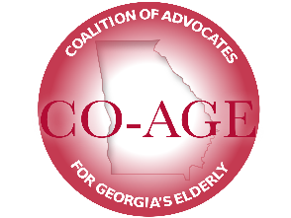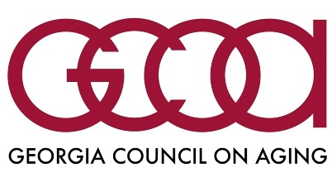

**Funding for Home and Community Based Services**

The Georgia Council on Aging and CO-AGE members advocate for increased funding for HCBS. On average, these services help delay nursing home care by 51 months. In-home services include home delivered meals, adult day care, respite care, home modification and more. The longer a person is able to stay at home with support, the more it saves taxpayer dollars.

* Over 6400 Georgians are on waiting lists for in-home services.
* In-home services cost a fraction of the cost of a nursing home bed.
  + Non-Medicaid in-home care averages $2145 per year.
  + State portion of CCSP Medicaid in-home care averages $5134 per year.
  + State portion of Medicaid nursing home bed averages $22,772 per year.
  + Every year, hundreds of people go off the waiting list and into a nursing home.
* In FY 2016, 428 people couldn’t wait any longer and went into a nursing home costing the state $8.8 million instead of $842,000.
* The Non-Medicaid Home and Community Based Services Program provides services to support and assist older Georgians in staying in their homes and communities. These services promote health and independence.

In September, Governor Kemp directed every department in state government to reduce spending this year starting Oct. 1 by 4%, and 6% next fiscal year. The Department of Human Services fulfilled their directive in part by cutting funding for HCBS and the meals program as follows:

Current year FY2020

* HCBS cut by $786,799
* Meals cut by $373,546

FY 2021

* HCBS cut by $1,142,699
* Meals cut by $714,739

The Georgia Council on Aging (GCOA) and the Coalition of Advocates for Georgia’s Elderly (CO-AGE) recommend that this funding be restored. It would keep service provider jobs in our local communities and it would help to leverage public-private partnerships in bringing solutions to the challenge of meeting the needs of an expanding older population.